|  |  |  |
| --- | --- | --- |
| Temasek Polytechnic | Description: ENG Logo | |
| Computer Programming for Problem Solving (ESE1006) – Project | | |
| Name: | | | Class: | |
| Tutor’s Comments: | | | Matric No: | |

**Project Specification**

1. **Problem Specification**
   1. Brief Description

To use the border-crossing travelers in different types of transport mode at Champlain Rouses Point, New York at the US-Canada border for the 13-year period from 2000 to 2012 data in a python program and display 4 different menu options plus a Quit option.

Based on the user’s selection, your program shall

1. Display the number of Bus Passengers crossing the border in 2006.

2. Of the user’s selected type of the border-crossing transport (e.g., Buses), display

a) the mean number of the travelers in different types of transport mode for each of the two 5-year spans of 2004 to 2008 and 2006 to 2010.

b) the minimum number of travelers in different types of transport mode in each of the periods and the years that the minimum occurs.

3. Of the user’s selected type of the border-crossing transport, find the mean number of travelers for the whole 13-year period. Display the travelers in different types of transport mode and the corresponding years that are lower than the mean value.

4. Make the following plots

a) Average number of Bus Passengers per Bus vs Year as a line plot.

b) Number of Personal Vehicles, Loaded Trucks vs Year as a bar chart.

Type of input data

A CSV file is used as the data source – brdrxingusc_dataset.csv

Amount of input data

The dimension of the input data is 4x14 (4 rows and 14 columns).

1. **Problem Analysis:**

You are required to analyse at least 2 functionalities to pass (Analyze all 4 to get more marks)

The program starts by displaying the main menu, which allows the user to enter a choice of 4 different menu options plus a Quit option. The dataset is a CSV file and therefore pythons default csv package is used to read the data. Matplotlib and NumPy are used for plotting. All options are described in detail below.

First option is to display the number of Bus Passengers crossing the border in 2006. It can be done by iterating through the data source and finding the year given and displaying the respective data.

Second option is to display the mean value of the number of travellers in different types of transport mode for each of the two 5-year spans of 2004 to 2008 and 2006 to 2010 and also to get the minimum number of travelers in different types of transport mode in each of the periods and the years that the minimum occurs. The first sub-problem can be solved using the inbuilt mean() function. The mean() function in the python statistics library can be used to directly compute the average of a list. Next, print the least value from the list.

Third option is to the find the mean number of travelers for the whole 13-year period for the user selected type. The index of the given type can be passed to the sorted data source and hence, returns the solution.

Finally, the fourth option is to create a:

1. Line plot
2. Bar chart

Matplotlib and NumPy can be used for plotting in python. Problem Statement 1 (Function 1)

What are the input data and how are they acquired?

The input data is a CSV file (brdrxingusc_dataset.csv) of size 4x14. Python’s default csv package is used to read the data. The csv.reader() function returns the data in a 2-dimensional matrix. This dataset is passed to the Main function.

What are the required output data?

The required output data is the number of Bus Passengers crossing the border in 2006.

How do you get the required output(s)?

* Iterating through the dataset to find the index of the required year.
* Using that index to access the data.

Problem Statement 2 (Function 2)

What are the input data and how they acquired?

The input data is a CSV file (brdrxingusc_dataset.csv) of size 4x14. Python’s default csv package is used to read the data. The csv.reader() function returns the data in a 2-dimensional matrix. This dataset is passed to the Main function.

A user chosen of transport is passed as parameter.

What are the required output data?

The required output data is:

* The mean number of travelers in different types of transport mode for each of the two 5-year spans of 2004 to 2008 and 2006 to 2010.
* The minimum number of travelers in different types of transport mode in each of the periods and the years that the minimum occurs.

How do you get the required output(s)?

* Iterating through the dataset and calculating the mean number.
* Finding the least value from that list.

Problem Statement 3 (Function 3)

What are the input data and how they acquired?

The input data is a CSV file (brdrxingusc_dataset.csv) of size 4x14. Python’s default csv package is used to read the data. The csv.reader() function returns the data in a 2-dimensional matrix. This dataset is passed to the Main function.

A user chosen of transport is passed as parameter.

What are the required output data?

The required output data is:

* The mean number of travelers for the whole 13-year period.
* The travelers in different types of transport mode and the corresponding years that are lower than the mean value.

How do you get the required output(s)?

* Iterating through the dataset and calculating the mean number.
* Finding the least value from that list.

Problem Statement 4 (Function 4)

What are the input data and how are they acquired?

The input data is a CSV file (brdrxingusc_dataset.csv) of size 4x14. Python’s default csv package is used to read the data. The csv.reader() function returns the data in a 2-dimensional matrix. This dataset is passed to the Main function.

What are the required output data?

The required output data is:

* A line plot with x-axis as Year and y-axis as Number of Bus Passengers.
* A bar chart with the Number of Personal Vehicles, Loaded Trucks vs Year

How do you get the required output(s)?

* First, required variables are initialized and declared with its respective values.
* For the line plot, Matplotlib.plot() function can be used.
* For the bar chart, Matplotlib.bar() function can be used.

1. **Problem Design**

Flowchart of *main* function

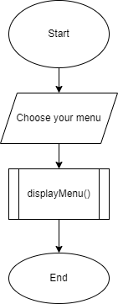

Flowchart of *displayMenu* function

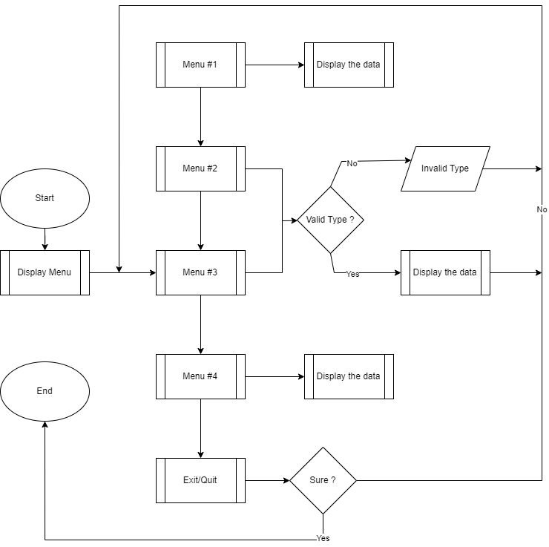

1. **Flow Charts for the 4 functions to be added here. Add as many pages as needed**

